Full neighbourhood profile for NE3 2JH

Intro:

**West Gosforth** is an electoral ward in the north of [Newcastle upon Tyne](https://en.wikipedia.org/wiki/Newcastle_upon_Tyne), [Tyne and Wear](https://en.wikipedia.org/wiki/Tyne_and_Wear), [England](https://en.wikipedia.org/wiki/England). It was created in 2004. The population of the ward is 9,681, increasing to 9,991 at the 2011 Census, 3.7% of the total population of upon Tyne. Car ownership in the area is 78.1%, higher than the city average of 54.7%.

What does this information tell you about the area?

It shows that the people in West Gosforth can afford to have a car more than the rest of Newcastle; this could show that they are more affluent so have more disposable income which means that they can afford to go to the gym. It also shows that the population is rising which means that they will have more customers.

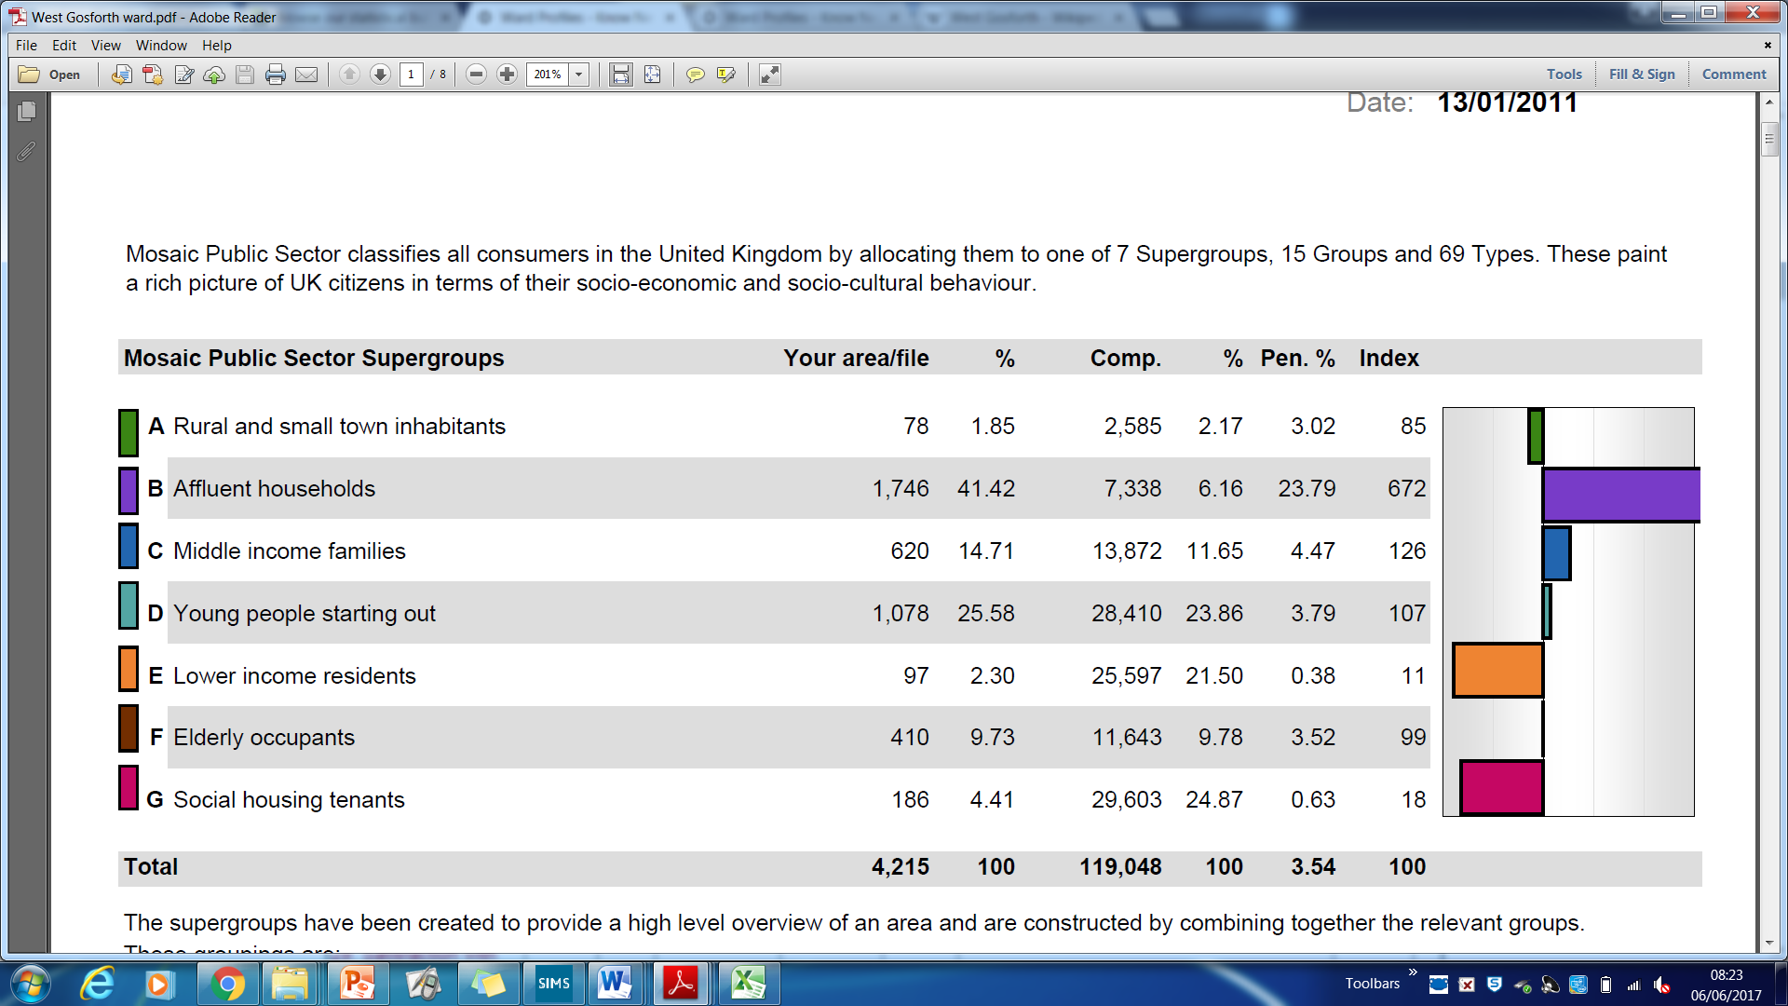

What impact might this information have on the selected business?

The majority of people in this area are affluent households. This means that they have a higher income which means that more of it is disposable so they will spend more of it on wants which means that they might sign up for a gym membership. This is good for Sport@Gosforth

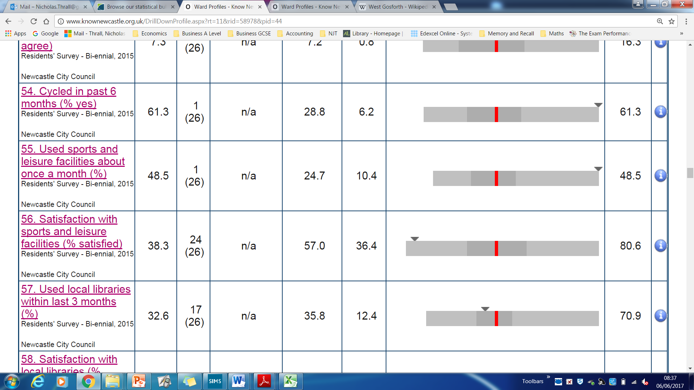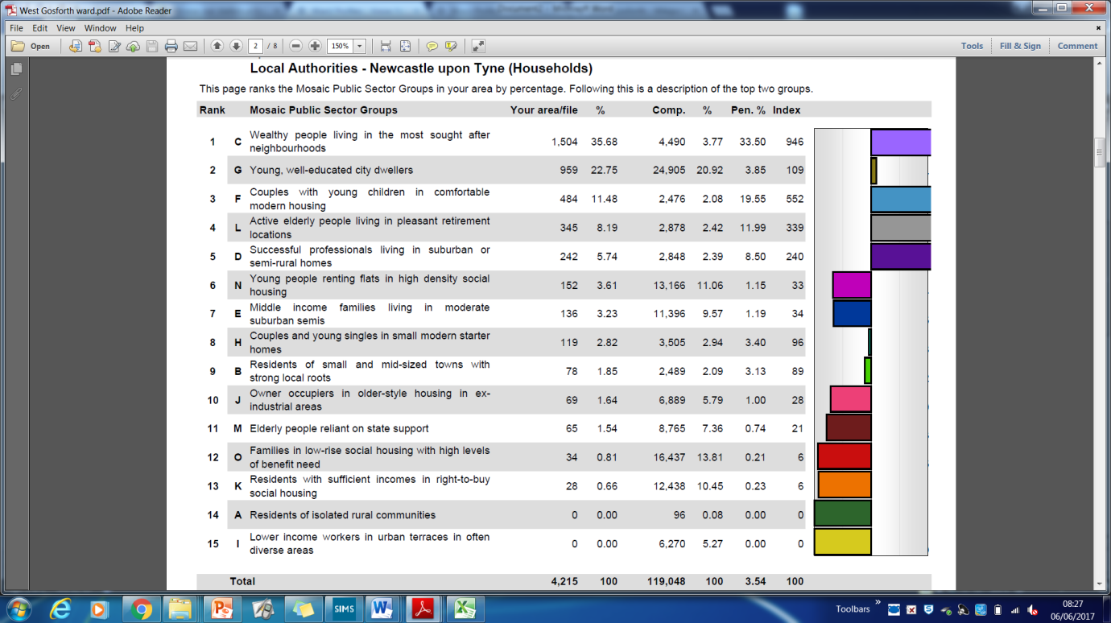

Describe the sort of customers your selected business might get.

The wealthier customers who can afford to spend more money on leisure instead of only spending on their needs; the highest area of households is the wealthy people who are living in the most sort after area which means there is a high amount of people who can afford to spend money on a gym membership

(Red Line is average for Newcastle overall, arrow indicates Gosforth specifically)

What impact might this have on your selected business?

Lots of people in the Newcastle area use sports facilities (gyms) which means that there is space in the market for another gym

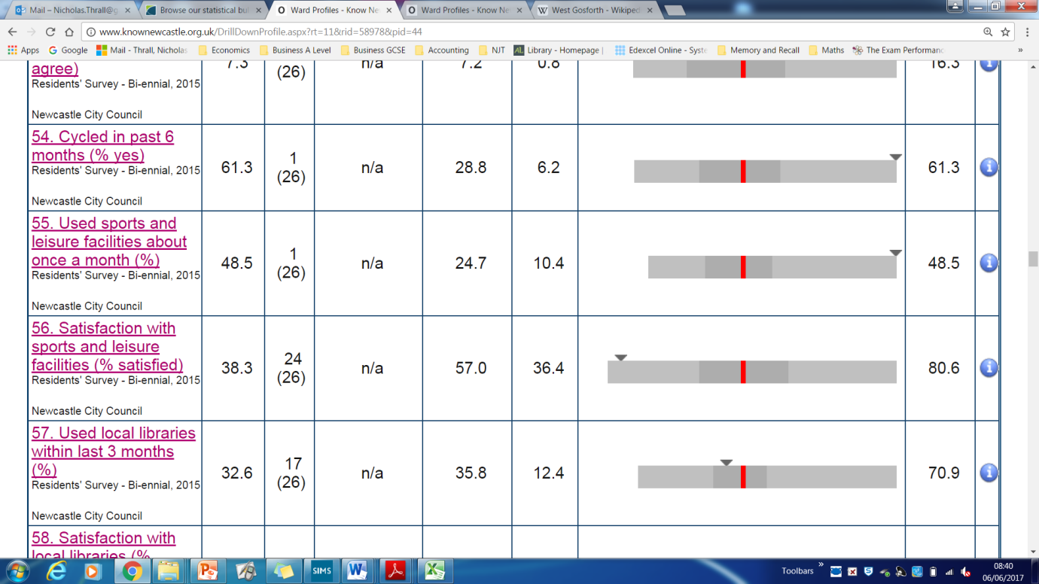

What impact might this have on your selected business?

This means that the people expect a high quality and no of the gyms that exist are very high quality. This means that people would be willing to try a new gym if it is high quality so Sport@Gosforth could use this as a marketing point